Portfolio Introduction
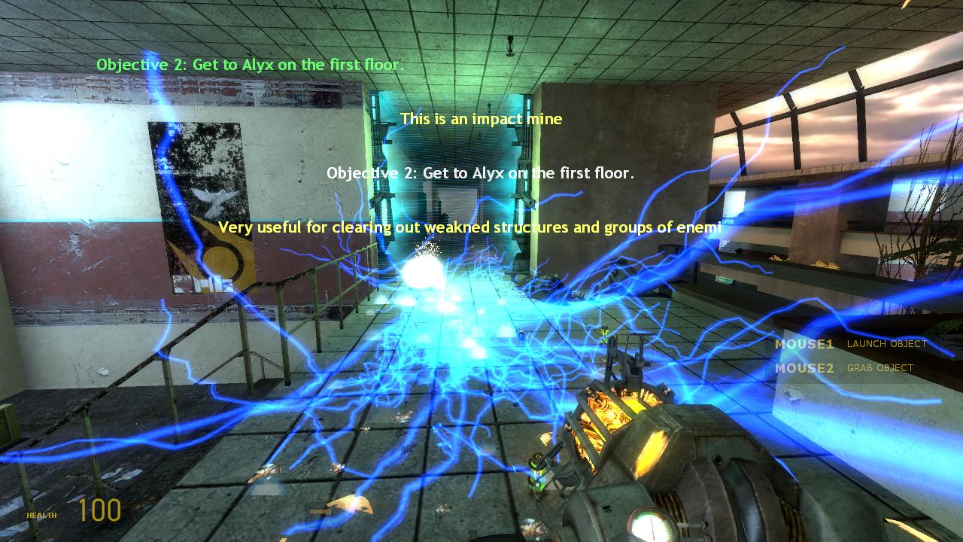
Figure 1 - A quick shot from the Half-Life 2: Episode 2 level, "It's Mine!"

This mini-portfolio is intends to show off my latest work, “It’s Mine!” a level created in Half-Life 2: Episode 2.
This mini-portfolio provides a brief walkthrough of “It’s Mine!” with various screenshots included. I want to give a good feel of my overall goals when creating the level, including what my goals were in terms of gameplay and level design and my aesthetic goals. I am extremely passionate about creating new worlds for the player to experience. Thank you for taking the time to look at my work. Please visit www.rafealunderwoodjr.com for a complete view of my portfolio.

Overhead Maps of all six floors
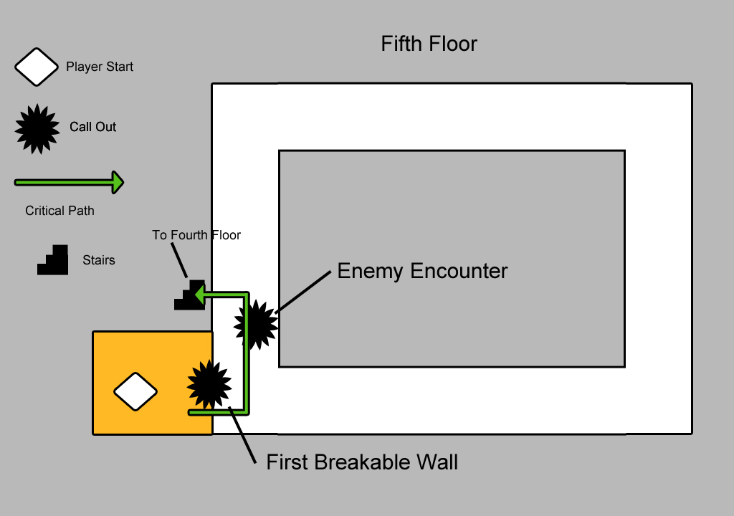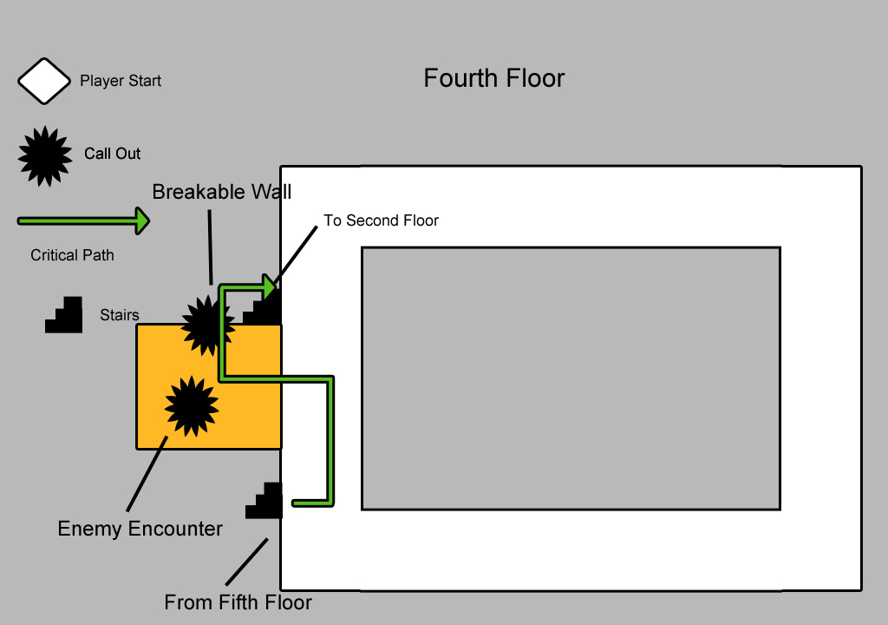
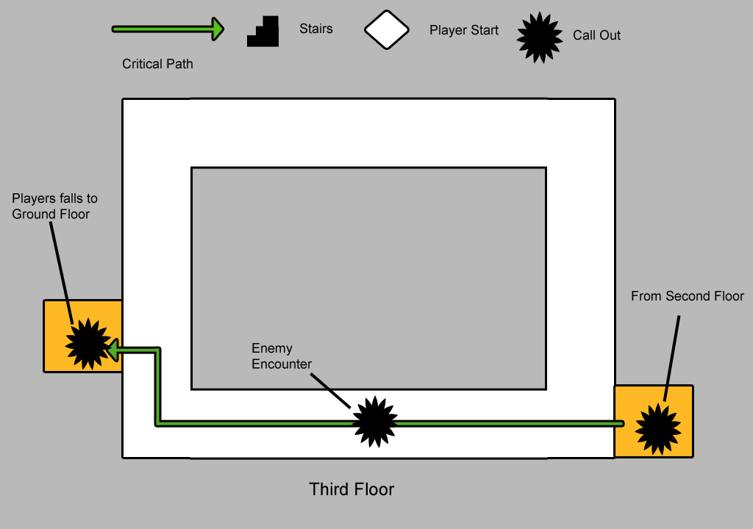
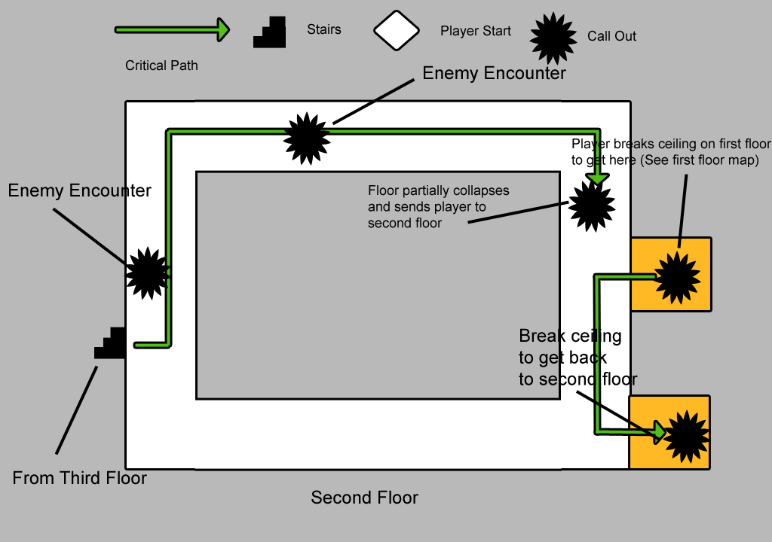
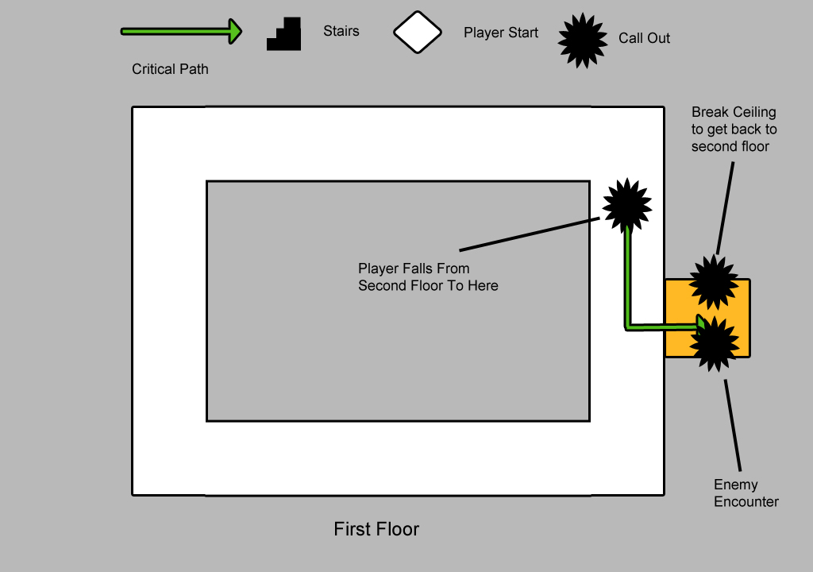

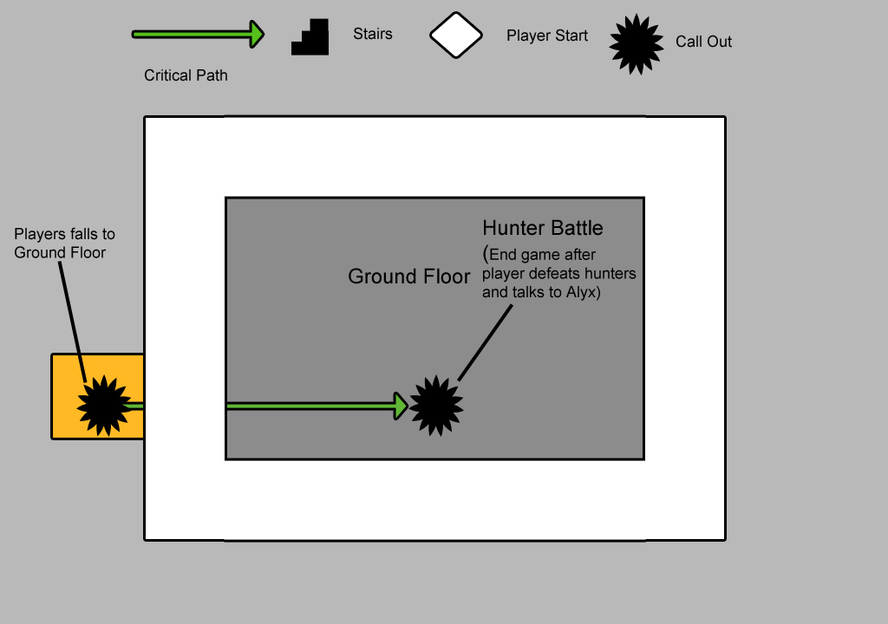

It’s Mine! – Half-Life 2: Episode 2 single-player map
When I designed “It’s Mine!”, I wanted to take advantage of Half-Life 2’s extremely robust entity-based scripting language while simultaneously making a visually polished play space. I wanted to create a fun mechanic that made full use of HL2’s dynamic physics system, which led to the creation of the Impact Mine. Designing a space that flowed well while creating interesting gameplay using the Impact Mine was also a huge goal when creating “It’s Mine!”. In terms of visuals, I wanted to create an impressive and somewhat awe-inspiring space that fit within the general aesthetic of the Half-Life 2 universe. I love the Half-Life 2 universe and the ambience it creates so I wanted to mimic that sense of atmosphere as close as possible.
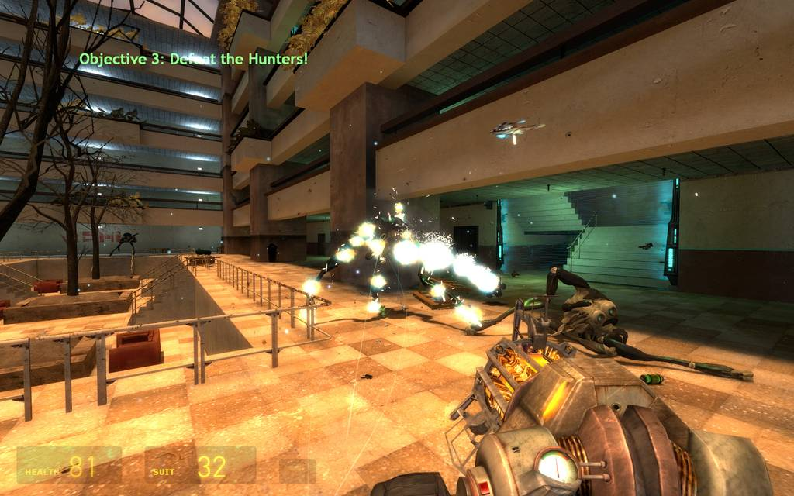
Figure 2 - Gordon taking on the hunters.

The biggest strengths of Half-Life 2 are the physics and the entity based scripting system. I wanted to create something exciting using the destructive capabilities of the physics while restricting players to use of only the Gravity Gun. This led to creating of The Impact Mine, a destructive object capable of breaking through weakened structures and handling large groups of enemies. The main challenge was setting up the breakable walls and the Impact Mine so that each would interact as smoothly as possible. I also had to script an event that would return the Impact Mine to the player, as it was very easy to lose track of the mine.
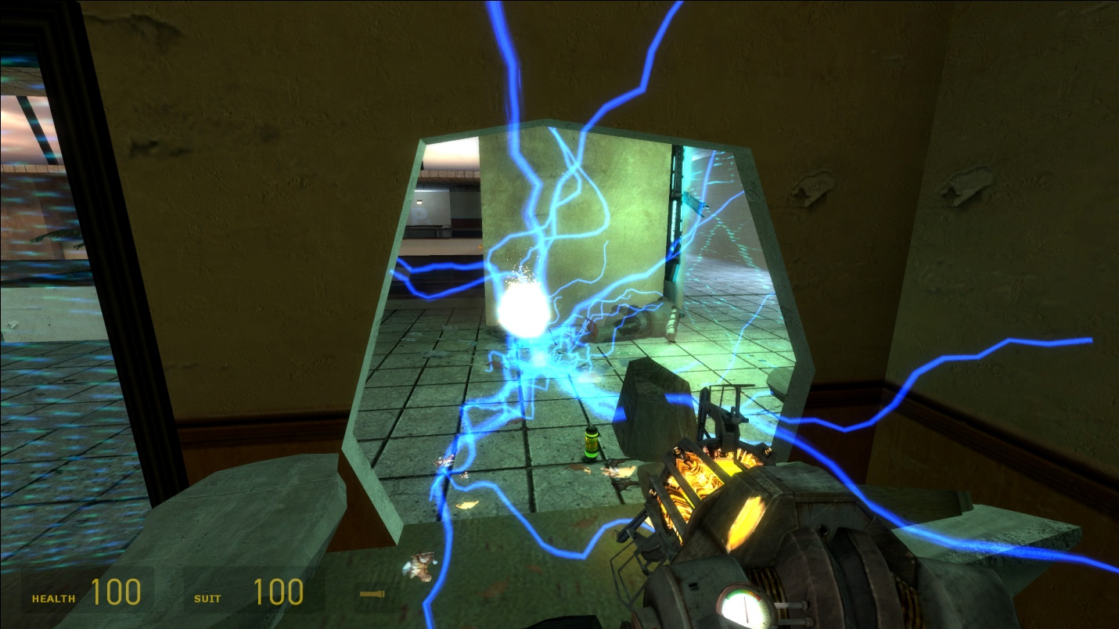
Figure 3 - A shot of the destructive power the Impact Mine is capable of. A brief note explaining the mine's capabilities gives the player a hint on what to do next.
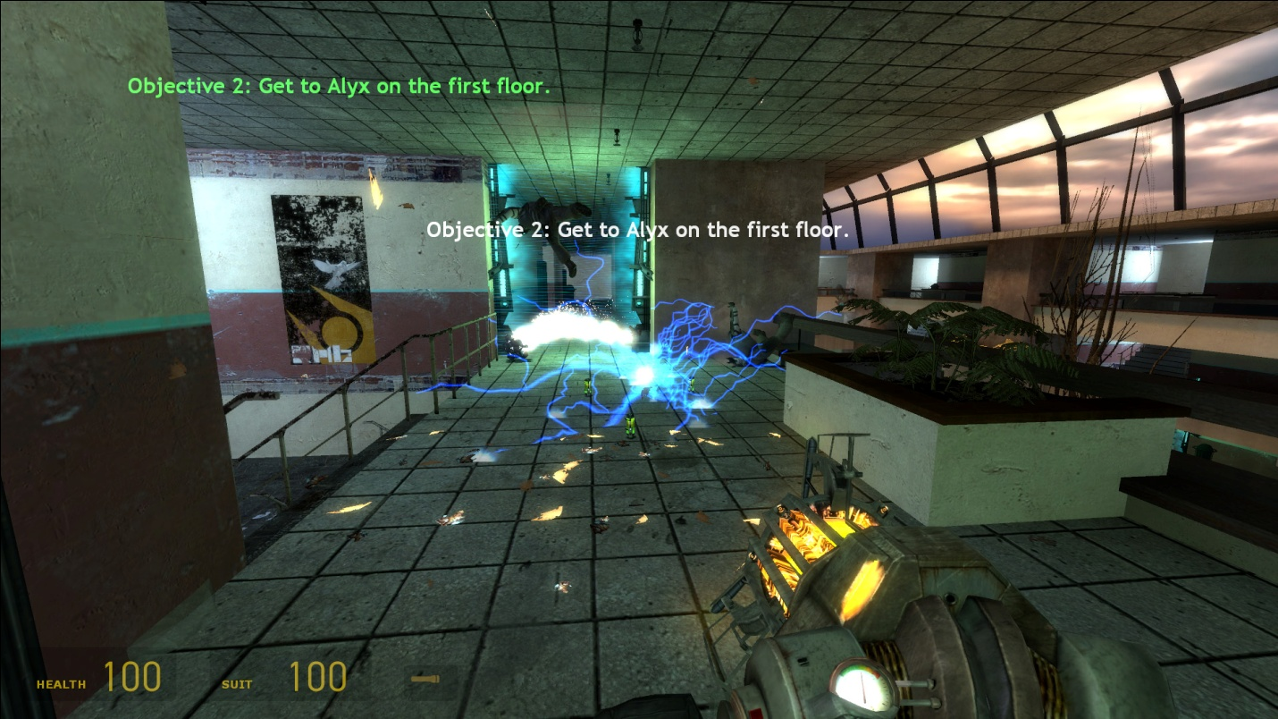
Figure 4 - Another demonstration of the mine's abilities. Here the player must take out a couple of Combine soldiers.

Designing an area to take advantage of the Impact Mine was also a challenge. I experimented with a couple of different layouts but in the end, I settled upon a large atrium. This allowed for a tight flow in a large structure while allowing room for a good deal of verticality. The player would traverse up and down multiple floors, taking on Combine forces while busting their way through walls and ceilings to reach the first floor and save Alyx from Hunters.
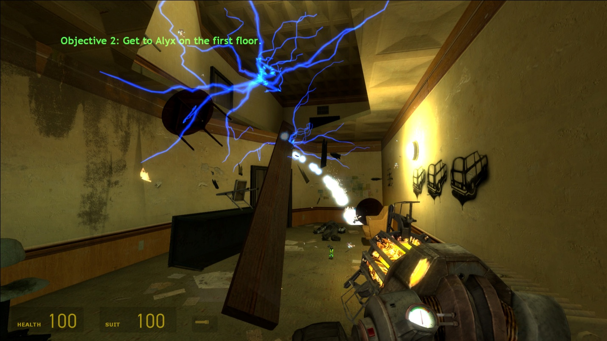
Figure 5 - Here the player must use the mine to bust through a weakened ceiling to climb up.
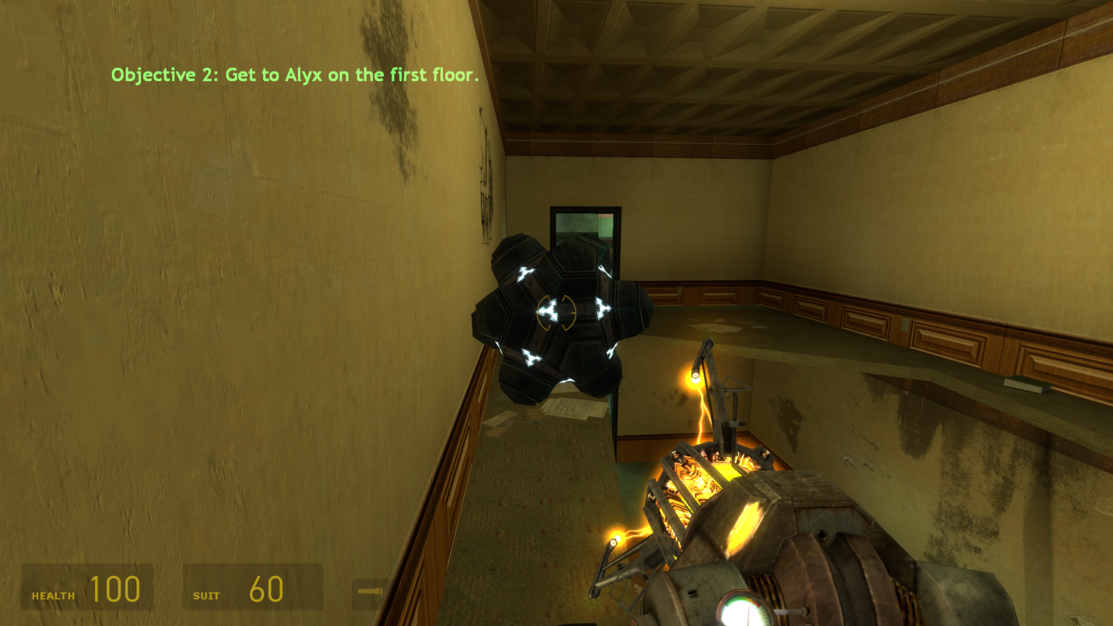
Figure 6 - The player makes their way to one of the upper floors using the Impact Mine.

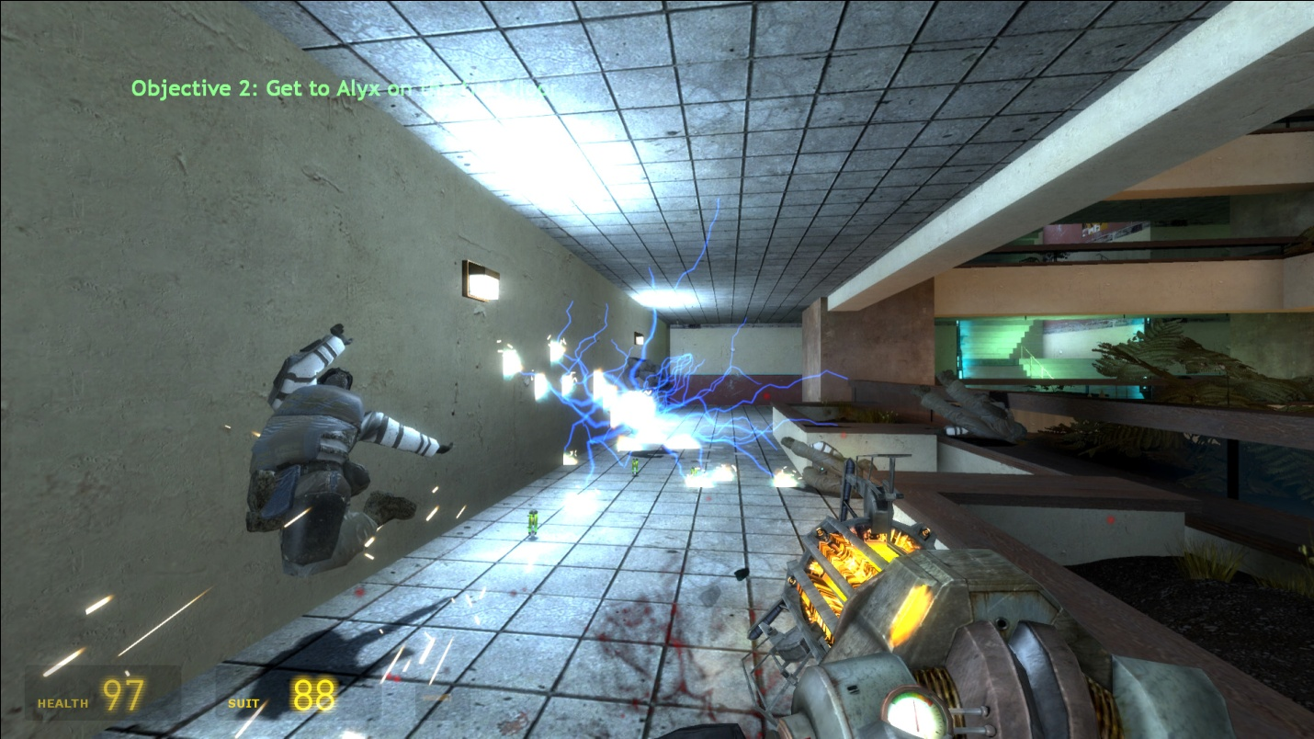
Figure 7 - A group of Combine soldiers attempting to impede the player's progress.

Aesthetically I was going for the look and feel of an office building that the people abandoned it shortly after the Combine showed up. Structurally I created a large atrium with a fairly large courtyard in the middle. Filling this space with the appropriate amount of clutter and detail was a significant challenge. At times I struggled with not making the area feel too cluttered while still portraying the fact that it people once used it for business purposes. The designers at Valve did a magnificent job of making of making their spaces feel populated while using a minimum amount of clutter, static meshes, and decals and I wanted to find that balance.
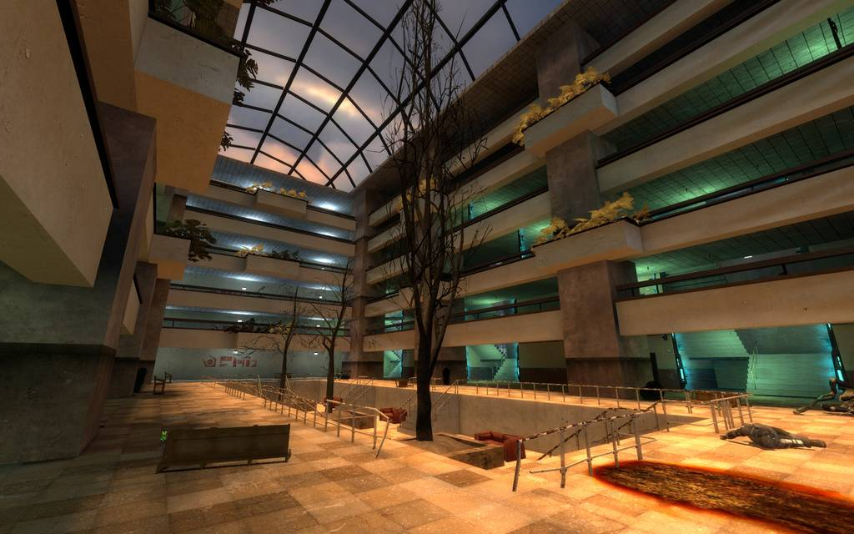
Figure 8 - A shot of the dusk lighting pouring in on the courtyard area.
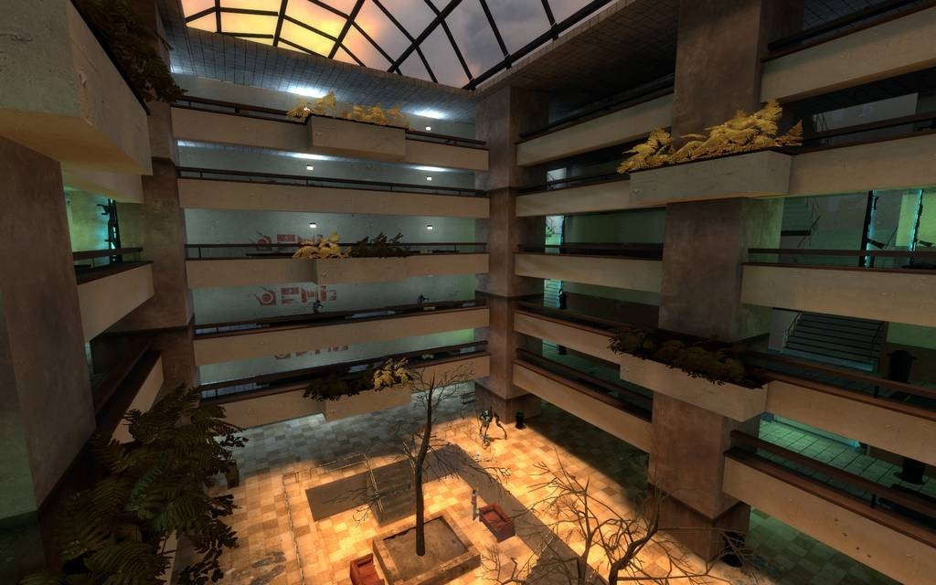
Figure 12 - An upper-center shot of the atrium.

